Plan and Report of Backend Development
Current Status: CRITICAL COMPROMISE. The backend is currently serving a PHP-based "scraper/spam" application (mimicking a Japanese retailer).
Transformation Goal: Complete backend remediation. Transition from Compromised PHP Legacy $\rightarrow$ Secure NestJS Modular Monolith (Enterprise Standard).
Scope: This is not a patch-up job. This is a "Strangler Fig" migration pattern to eliminate the malware and establish a hardened, scalable baseline.

Vulnerability / Risk | Severity | Technical Analysis
Unrestricted Remote Code Execution (RCE) | CRITICAL | The active PHP environment likely allows arbitrary file uploads (web shells) in /images or /cache directories, granting attackers full shell access.
Missing Authentication Layer | CRITICAL | The current admin panels (likely /admin or /dashboard) typically use default or hardcoded credentials common to mass-deployed spam kits.
SQL Injection (SQLi) Surface | CRITICAL | Legacy PHP mysql_query or unparameterized PDO calls are standard in these scripts, exposing the entire database to dumping.
Data Exfiltration Pipelines | CRITICAL | "Checkout" forms are likely wired to send credit card data (PAN/CVV) via PHP mail() to external drop servers.
Zero CI/CD / FTP Deployment | HIGH | Updates are likely performed via FTP, meaning no version control, no rollback capability, and high risk of overwriting critical files.
Lack of WAF / Rate Limiting | HIGH | No defence against L7 DDoS or brute-force attacks on login endpoints.

1️ Backend Risk & Weakness Audit (Current State)

2️ Production Hardening Plan (Actionable & Technical)
This plan mandates a Greenfield Re-deployment using the intended NestJS + TypeScript stack.

A. Security Hardening (Application Layer)
- Mitigation: Authentication & Zero-Trust
  - Strategy: Implement OAuth2 / OIDC (Auth0 or AWS Cognito) instead of building custom auth.
  - Tactical Implementation:
    - Use Passport.js strategies in NestJS.
    - Token Rotation: Implement Refresh Tokens (stored in httpOnly cookies) and Short-Lived Access Tokens (15 min).
    - RBAC Guard: Create a custom @Roles('admin', 'doctor') decorator using NestJS Reflector to enforce permission checking before route execution.
- Mitigation: API Surface Protection
  - Tools: helmet (HTTP Headers), express-rate-limit, class-validator.
  - Action:
    - Enable HSTS (Strict-Transport-Security) with a 1-year duration.
    - Throttling: Apply ThrottlerModule (NestJS) globally. Limit: 100 req/min for general APIs, 5 req/min for login.
    - Input Sanitization: Use class-validator with whitelist: true and forbidNonWhitelisted: true in the global validation pipe to strip malicious payloads automatically.

B. Infrastructure Hardening (DevOps)
- Mitigation: Immutable Infrastructure
  - Strategy: Docker Multi-Stage Builds.
  - Implementation:
    - Stage 1 (Build): Install dev dependencies, compile TypeScript.
    - Stage 2 (Run): Copy only dist folder and node_modules (production only). Run as Non-Root User (e.g., USER node).
    - Outcome: Reduces image size (<100MB) and removes attack tools (compilers, shells) from the production container.
- Mitigation: Orchestration & Scaling
  - Platform: AWS EKS (Kubernetes) or ECS Fargate.
  - Config:
    - Horizontal Pod Autoscaler (HPA): Scale pods based on CPU utilization (>70%).
    - Pod Disruption Budgets: Ensure at least 2 replicas are always alive during updates.
- Mitigation: Secrets Management
  - Action: NEVER use .env files in production images.
  - Tool: AWS Secrets Manager or HashiCorp Vault. Inject secrets at runtime as environment variables.

C. Database Hardening (PostgreSQL)
- Mitigation: Data Integrity & Performance
  - Optimization: Enable Connection Pooling (using PgBouncer) to handle thousands of concurrent connections without overwhelming the DB.
  - Encryption:
    - At Rest: Enable AES-256 encryption on the AWS RDS volume.
    - In Transit: Enforce SSL mode (sslmode=require) in the TypeORM/Prisma connection string.
  - Resilience: Deploy Read Replicas in a different Availability Zone (AZ). Offload GET (reporting) queries to replicas; keep POST/PUT on the primary.

D. Performance Optimization
- Caching Strategy (Layered):
  - Edge Cache (CDN): Cloudflare for static assets (images, JS bundles).
  - API Response Cache: Redis. Cache expensive GET endpoints (e.g., /patients/summary) for 60 seconds using NestJS CacheInterceptor.
  - Database Query Cache: Cache complex JOIN results at the ORM layer.
- Async Processing:
  - Tool: BullMQ (Redis).
  - Use Case: Offload heavy tasks (Email sending, PDF generation, AI inference) to background worker nodes. Never block the main Event Loop.

E. Observability & Monitoring
- Centralized Logging:
  - Stack: ELK (Elasticsearch, Logstash, Kibana) or Datadog.
  - Format: Enforce JSON Structured Logging (using winston or pino). This allows logs to be queried by fields (e.g., level="error" AND context="AuthService").
- Distributed Tracing:
  - Tool: OpenTelemetry.
  - Goal: Visualize the full lifecycle of a request as it flows from Gateway $\rightarrow$ Service A $\rightarrow$ Database $\rightarrow$ Redis.

3️ Refactored Production-Grade Architecture
Design Pattern: Modular Monolith (with Microservices Readiness)
Rationale: Avoids the operational complexity of full microservices while keeping code boundaries clean for future splitting.
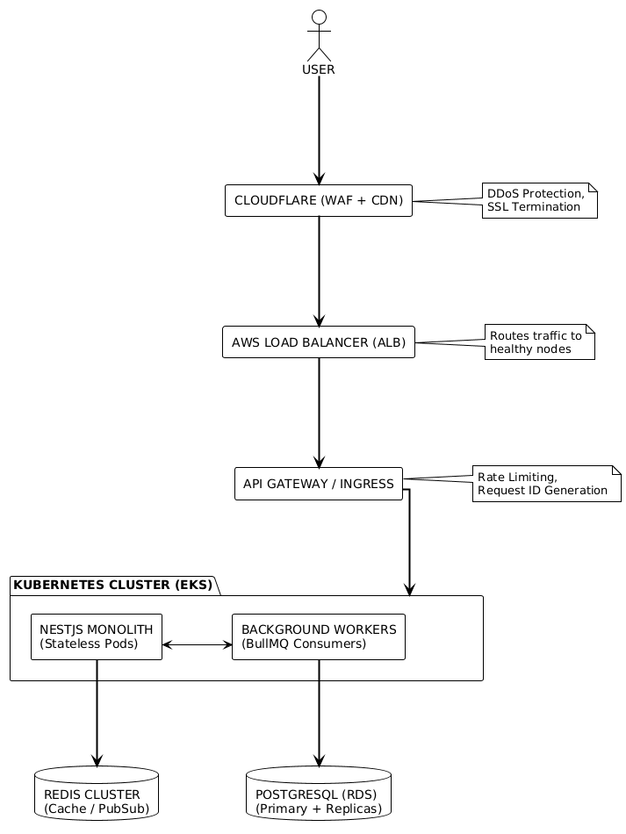

Architecture Highlights:
- Stateless Backend: The NestJS pods hold no data. Sessions are stored in Redis or handled via stateless JWTs. This allows the cluster to kill/spawn pods instantly.
- Async Decoupling: The API accepts the request and immediately returns 202 Accepted for heavy tasks, while the "Background Workers" process the job via Redis queues.

4️ Scalability Roadmap
- Phase 1: Remediation (Weeks 1-4)
  - Goal: Secure the perimeter.
  - Actions: Purge the PHP malware. Re-image the server. Deploy the "Skeleton" NestJS app with Auth0 and WAF.
  - Justification: Stop the bleeding (data theft/reputation loss).
- Phase 2: Reliability (Weeks 5-8)
  - Goal: Zero data loss.
  - Actions: Setup RDS with automated backups (PITR). Implement CI/CD pipelines with automated testing.
  - Justification: Ensure that when development accelerates, the infrastructure doesn't break.
- Phase 3: Performance (Weeks 9-12)
  - Goal: <200ms API Latency.
  - Actions: Implement Redis caching. Tune database indexes. Optimize Docker images.
  - Justification: User experience (doctors cannot wait for slow loading screens).
- Phase 4: Scale (Week 13+)
  - Goal: 10k+ Concurrent Users.
  - Actions: Implement Read Replicas. Enable Horizontal Pod Autoscaling. Break out "Reporting" into a separate microservice.
  - Justification: Prepare for enterprise hospital deployment.

5️ Risk Mitigation Matrix
Risk | Severity | Proposed Fix | Impact
API Key Leakage | High | Vault / Secrets Manager integration. Git hooks to block commits with keys. | Prevents complete infrastructure takeover.
DDoS Attack | High | Cloudflare WAF + Rate Limiting Middleware. | Ensures uptime during attacks.
Slow DB Queries | Medium | Index Analysis + Read Replicas for analytics. | Prevents connection pool exhaustion.
Bad Deployments | Medium | Blue-Green Deployment strategy. | Allows instant rollback if a bug hits prod.
Malicious Input | Critical | Class-Validator (Whitelist) + Sanitization Pipes. | Neutralizes SQLi and XSS attempts.

